CREATE DATABASE hostelfoodmanagementsystem;

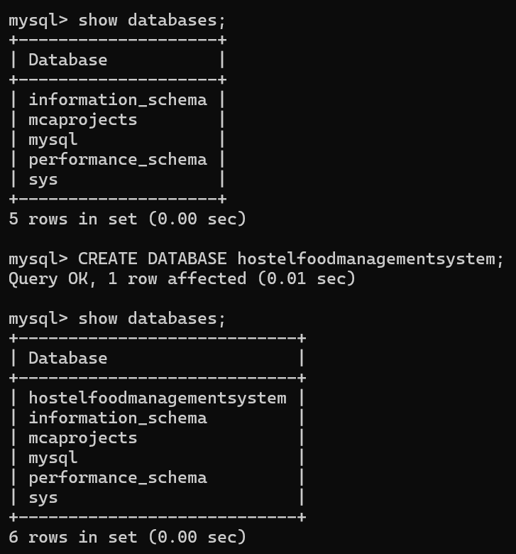

USE hostelfoodmanagementsystem;

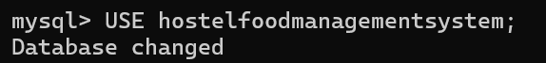

**-- Students Table**

CREATE TABLE students (

enrolment_no VARCHAR(20) PRIMARY KEY,

faculty_no VARCHAR(20) UNIQUE NOT NULL,

name VARCHAR(100),

dob DATE,

hostel_name VARCHAR(100)

);

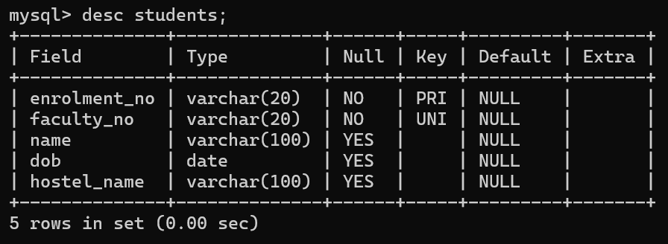

**-- Vendors Table**

CREATE TABLE IF NOT EXISTS vendors (

vendor_id INT AUTO_INCREMENT PRIMARY KEY,

username VARCHAR(50) UNIQUE,

password VARCHAR(50)

);

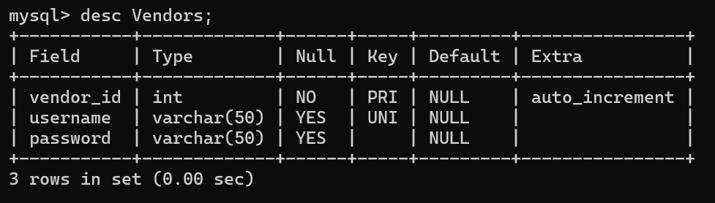

**-- Meals Table**

CREATE TABLE meals (

meal_id INT AUTO_INCREMENT PRIMARY KEY,

vendor_id INT,

meal_name VARCHAR(30),

meal_type VARCHAR(20),

FOREIGN KEY (vendor_id) REFERENCES vendors(vendor_id)

);

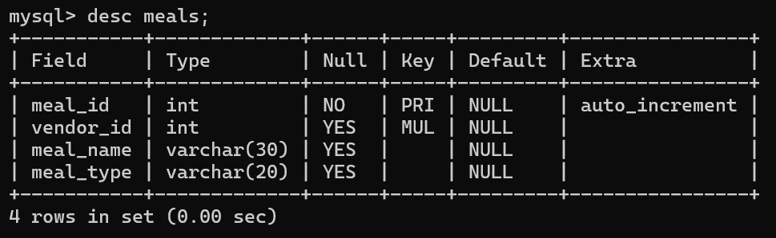

**-- Meal Counter Table**

CREATE TABLE meal_counter (

counter_id INT AUTO_INCREMENT PRIMARY KEY,

enrolment_no VARCHAR(20),

meal_id INT,

meal_datetime DATETIME DEFAULT CURRENT_TIMESTAMP,

FOREIGN KEY (enrolment_no) REFERENCES students(enrolment_no),

FOREIGN KEY (meal_id) REFERENCES meals(meal_id)

);

